**Property Indication**

1. **Property Information:**

|  |  |
| --- | --- |
| **Property Address:** | Lot No.3578, Street 2 thnou, Phum 1, S/K No.3, Krong Preah Sihanouk, Sihanouk Province |
| **Property Type** | A parcel of vacant land purchased for Condo project |
| **Land Size** | 12,245sqm |
| **Building Size:** | n/a |
| **Date Inspection** | 10-Aug-2017 |

1. **Maps:**

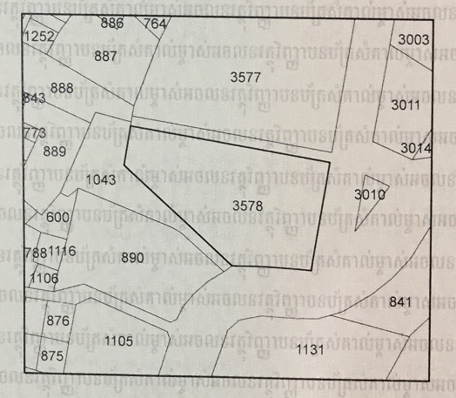

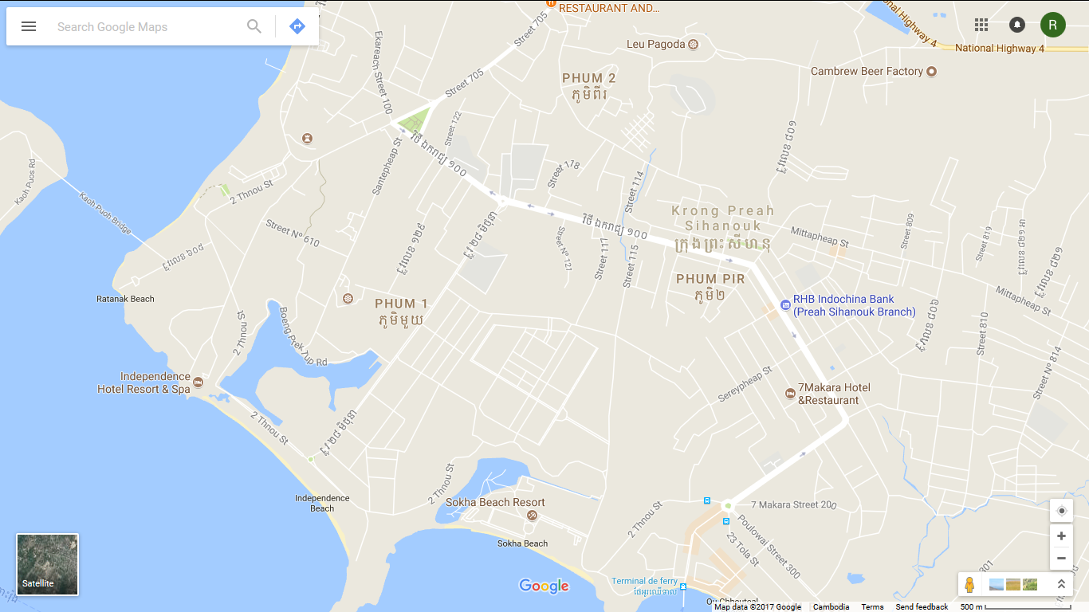

Subject property

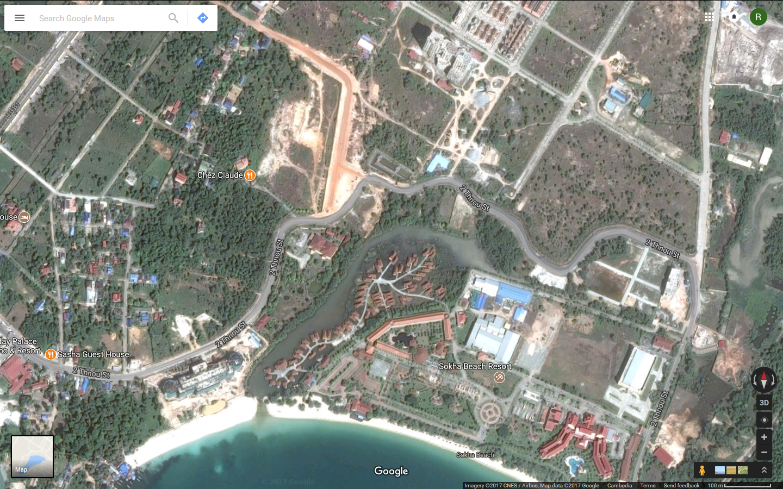

Subject property

1. **Property Photo:**

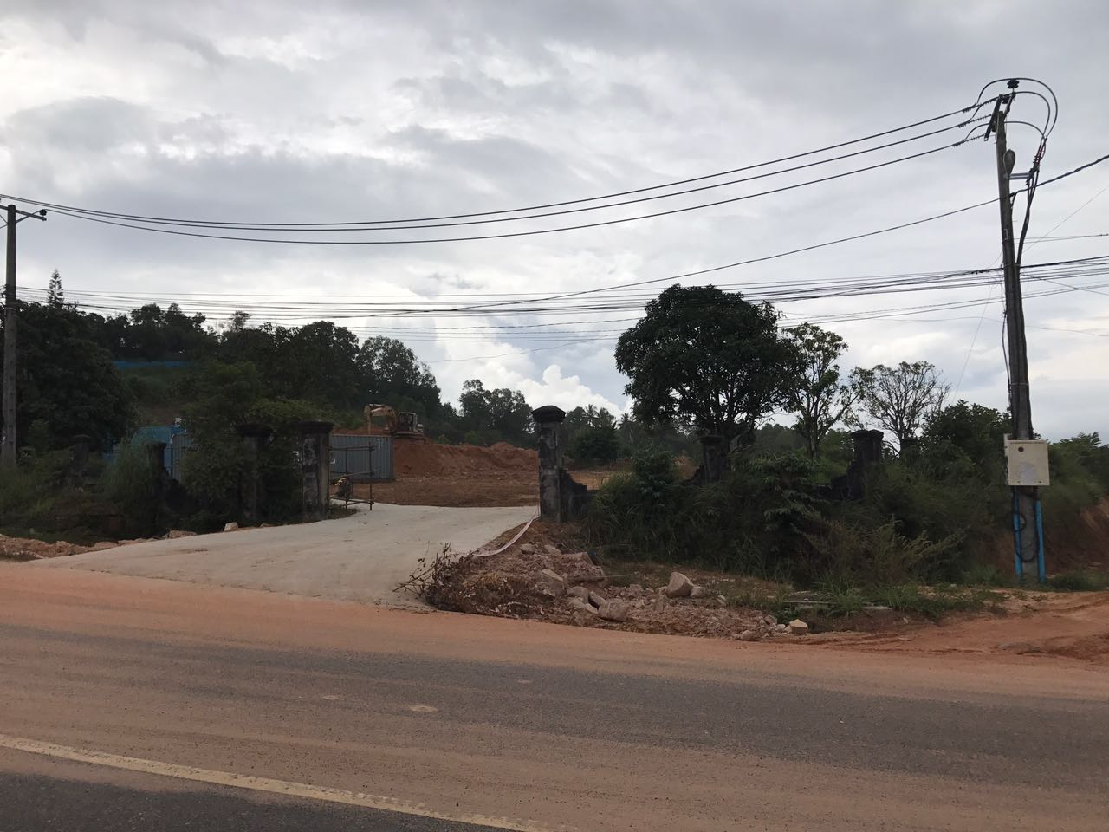

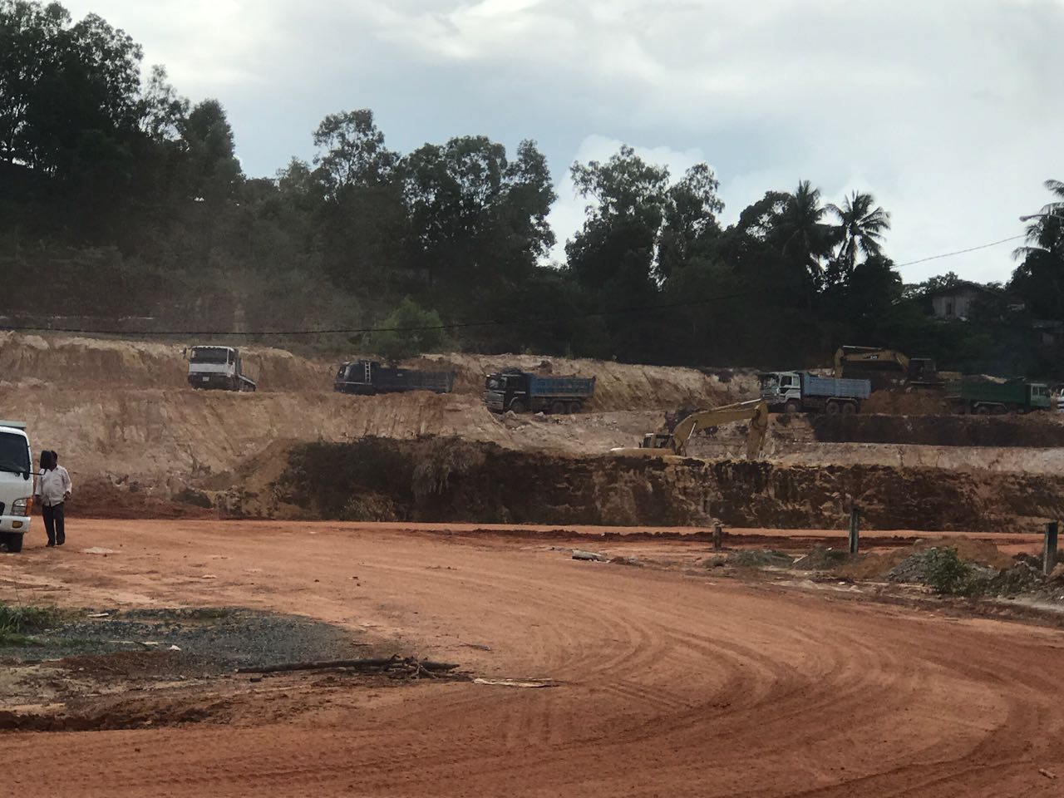

1. **Surrounding property:**

